Exciting Events in 2017
March: Sahara p.7
April: Virgin London Marathon p.2
London to Paris Cycle p.6

June: Staplehurst 10K p.3

July: British 10K p.2
St Ives 10K p.4 tbc
Virgin London Triathlon p.2
Iceland Trek p.8
Prudential Cycle p.2
August: Maidstone 5K p.3
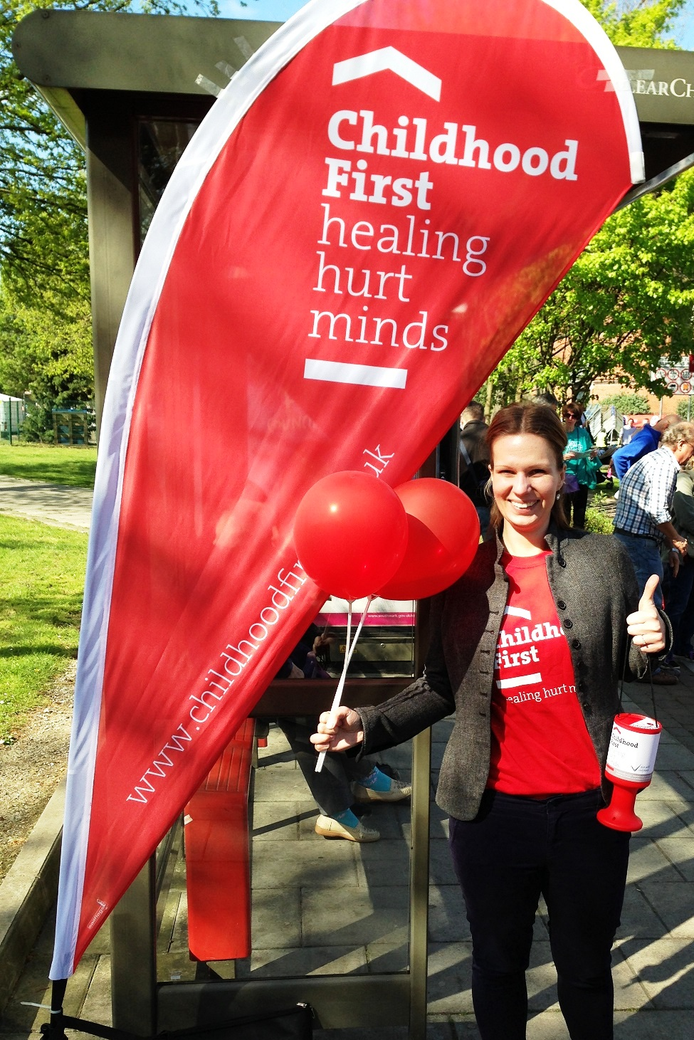

September: London to Brighton Cycle p.7
China Trek p.8
Kilimanjaro Trek p.7
Ben Nevis p.7
October: Peterborough Half Marathon p.4
Vietnam to Cambodia Cycle p.6

November: Norwich Half Marathon p.5
December: Santa Run 5K and 10K p.2

Any Dates: Abseil p.4, Skydiving p.5
2018: Lets Trek for Children. P.8

London:
Virgin London Marathon 23rd April 2017
Last year we had 29 people running for us! We are
now taking applications for London Marathon 2017
-as a part of our team you will receive a
vest and fundraising and training information
and our support over the preceding months!
British 10K tbc July 2017
This extremely popular event in the centre of London starts at 9.35am at Hyde Park Corner and ends at Whitehall. We now have 2 spaces left in our team-we ask you to raise £150 and pay a registration fee of £30.
Virgin London Triathlon 22nd – 23rd July 2017
Take part individually choosing one of 10 distances from 400m Swim/10km Bike/2.5km Run, up to 1500m Swim/90km Bike/10km Run. Or enter as a team choosing one part each from the cycle, swim and run. Enter via the website and then contact us to join our team.
http://thelondontriathlon.com/
Prudential Ride London, Cycle 28th – 30th July 2017
20,000 amateur cyclists take on a challenge of riding 100 miles through London and the Surrey Hills, cyclists will start over a two-hour period from Queen Elizabeth Olympic Park. Join via their website and then contact us! https://www.prudentialridelondon.co.uk/
Santa Run December 2017, date tbc http://www.doitforcharity.com/running.aspx For £22 you register for this fun 5K or 10K run and get your Santa suit included!! It all takes place at Victoria Park.

Kent:
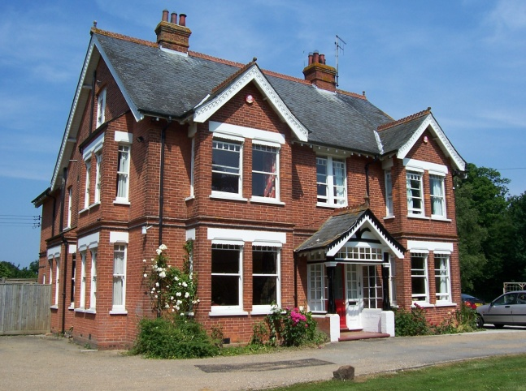

Maidstone 5K August 2017
The run starts at 11am to the north of Mote Park; is a beautiful 180 hectare, multi use public park in Maidstone, Kent. It is £11.49 for adults and £5.49 for concessions. All you need to do is register at http://www.bigfunrun.com/?maidstone and then raise as much sponsorship for Childhood First as you can-we recommend a target of £100.

Staplehurst 10K 11th June 2017
This takes place at 10am the Surrenden Road Playing Fields, to register you need to visit: http://www.nice-work.org.uk/events.php?id=42 and pay a registration fee of £16.50.
It is an event only in its 9th year and has a good size group of runners of 300, so it is great for those starting out in 10K running as it is also relatively flat and has the bonus of chip timing to give you accurate results if you are aiming for a personal best!

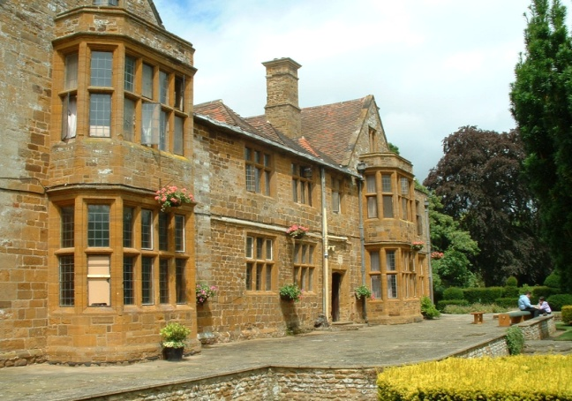
Northamptonshire:

St Ives 10K & Fun Run entry opens in January 2017
This 10k race consists of an undulating "out & back" course on mainly traffic free roads and costs just £12 to register from January at
http://www.huntsac.org.uk/entry.asp but there is a 700 person limit.
You need to be at least 15 years old and will be given a chip timer to wear.
National Abseil Centre any dates!
http://www.nationalabseilcentre.co.uk/
At 418 feet (127m), the National Abseil Centre is the tallest
permanent abseil tower in the world. Located in
Northampton, it costs £95 to register and you need to be at least 14 years old and under 136kg.
Peterborough Half Marathon and Fun Run 8th October 2017
Its costs £25 to register for the half marathon run; starting at 10.30am and half marathon wheel chair event; starting at 10.25am. Both start from The Embankment, next to the River Nene, then runners will head in and around Peterborough before reaching the finish line back at The Embankment. The fun run costs £9 and starts at 10am. To register please visit http://www.perkinsgreateasternrun.co.uk/fun-run/start-finish-info
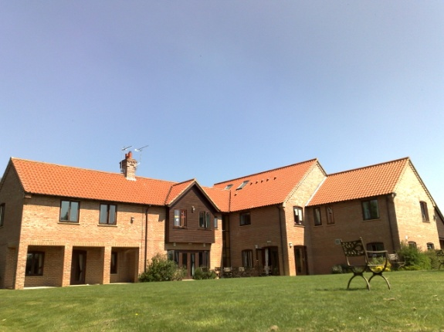
Norwich:

Norwich Half Marathon 9th November 2017
http://www.cityofnorwichhalfmarathon.com/
You must be at least 17 years old in November 2015 and registration costs £23, the race was full by mid October for the 2014 event.
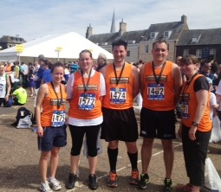
Race is at the Norfolk Showground, Dereham Road, Costessey, Norwich, NR5 0TT.

Skydiving
We will receive an average donation of £140 and you will receive your parachute jump for FREE. Choose from the following locations:
Tandem Skydive: £395*
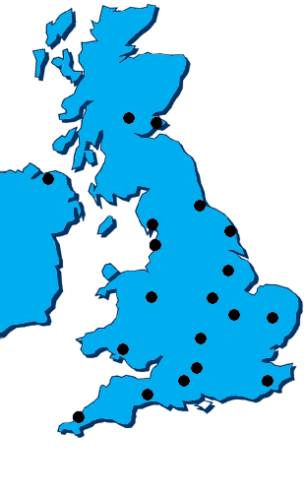
Static Line Square: £360
Accelerated Freefall: £535
*£450 in Scotland and Northern Ireland

Cycling
London to Paris Cycle 19th – 23rd April 2017
Minimum sponsorship: £1,525
Registration fee: £99
Day 1: London to Calais
Day 2: Calais to Abbeville
Day 3: Abbeville to Beauvais
Day 4: Beauvais to Paris
Day 5: Paris to London
http://www.londonparisbikeride.co.uk/itinerary.aspx

London to Brighton Cycle 17th September 2017
http://www.londonbrightoncycle.co.uk/ It is £40 to take part and you are asked to raise at least £100.
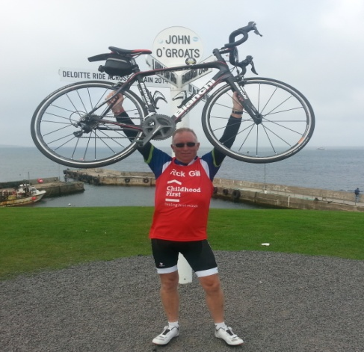

Vietnam to Cambodia 19th - 29th October 2017
Minimum Sponsorship: £3190
Registration Fee: £349
11 days travelling through various cities including Ho Chi Minh City, Phnom Penh, Kampong Thom and Angkor Wat
http://www.doitforcharity.com/vietnam-to-cambodia-cycle-2017.aspx?ad=eventsummary7

Trekking-UK
Ben Nevis Challenge 22nd – 24th September 2017
Minimum sponsorship: £560
Registration fee: £99
A 9 mile ascent which can be used for training towards a bigger challenge such as Kilimanjaro or as a standalone event.
http://www.doitforcharity.com/difc-ben-nevis-challenge-2017.aspx?ad=eventsummary3

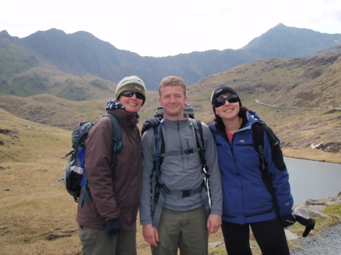

Trekking-Overseas

Kilimanjaro Trek 27th September- 7th October 2017
Minimum sponsorship: £4340
Registration Fee: 3499
10 Days-
http://www.doitforcharity.com/kilimanjaro-trek-october-2017.aspx?ad=eventsummary11
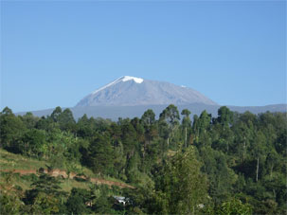
Sahara Trek 7th - 15th March 2017
Minimum sponsorship: £2,000
Registration Fee: £299
9 days; Flying to and from Ouarzazate.
http://www.doitforcharity.com/sahara-trek-march-2017.aspx?ad=eventsummary10

Iceland Trek 12th – 16th July 2017
Minimum sponsorship: £2,380
Registration Fee: £299
5 Days – Returning to Reykjavik
http://www.doitforcharity.com/iceland-trek-july-2017.aspx?ad=eventsummary1

China Trek 7th – 16th September 2017
Minimum sponsorship: £2,840
Registration Fee: £349
9 Days- Great Wall, to Huangyaguan, to Mountain Village to Jinshanling, to Guebikou, to Jinshanling, to Mutianyu, to Beijing
http://www.doitforcharity.com/china-trek-september-2017.aspx?ad=eventsummary8

Trek for Children 25th May – 2nd June 2018
Minimum sponsorship: £2,900
Registration Fee: £299
Hike the Himalayas in beautiful Nepal
11 days-: London to Kathmandu, to Syauili, to Ghandruk, to Tadapani, to Ghorepani, to Poon Hill, to Tirkedunga, to Nayapool.
http://www.actionforcharity.co.uk/eventdetailsnew2.php/urlsearch/Let's-Trek-for-Children-Great-Wall-of-China-Trek-2018

Corporate Teams

If you have chosen Childhood First as your charity of the Year the events in this booklet are a great way to raise money whilst also working as a team for a shared goal; both in fundraising and reaching a destination!
Contact us in the fundraising team for more information.

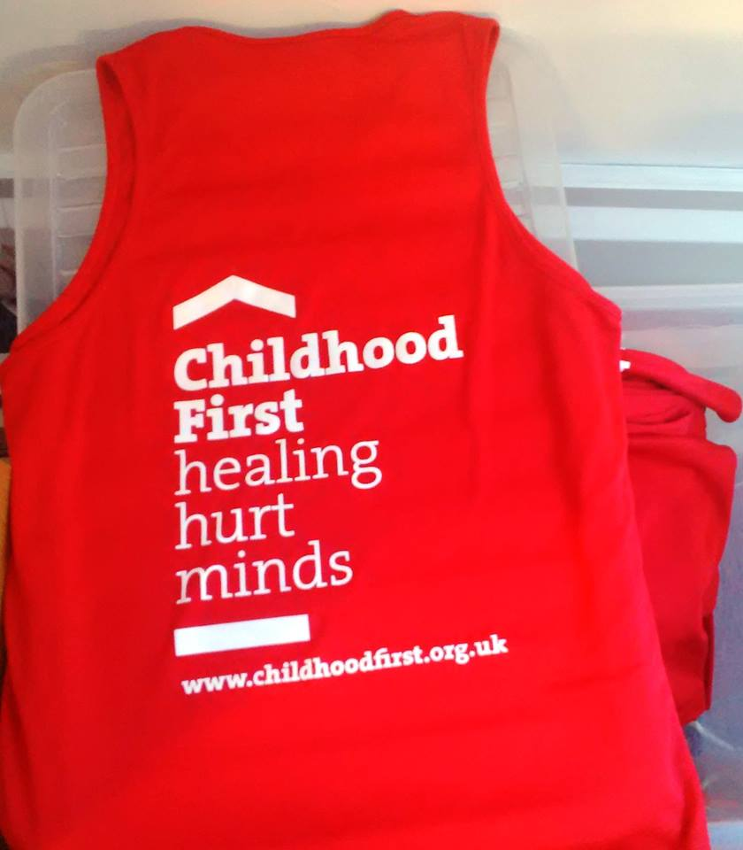

Contact Details

Holly de la Nougeréde
Communications and Events Fundraiser

Roger Stephenson
Business Development Director

Nick Johnson
Trust and Statutory Fundraiser

events@childhoodfirst.org.uk

210 Borough High Street
London, SE1 1JX
02079287388

Find us on Facebook
Follow us on Twitter

www.childhoodfirst.org.uk/get-involved/fundraising-events/

